1. Grover

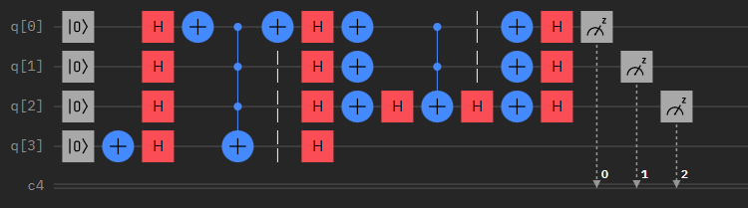

초기 목표: Grover search Algorithm을 사용하여 연속된 weighted K-Sat problem 해결

1. Simple grover search Algorithm 구현

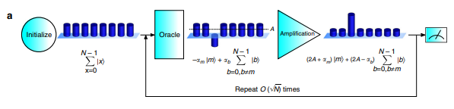

Step 2)-(3)

Step 2)-(1)

Step 1)



1. The algorithm begins with the state ${|0>}^{⊗n}$. The Walsh-hadamard gate transforms in the equal superposition state.



1. Grover iteration is broken up into four steps.
2. The marked state inverse. 



1. Applying the Hadamard transform



1. Perform a conditional phase shift



1. Applying the Hadamard transform



Combine the effect of steps (2), (3), (4)



1. Circuit Design for k-coloring Problem

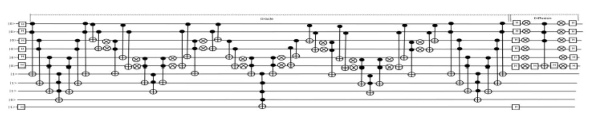

Oracle operator

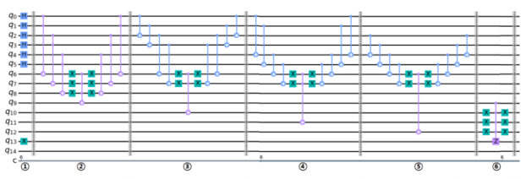

1. q9 to q12 represent the state of the coloring condition. Steps 2 to 5 store the state to q9-q12. Step 6 combines the result and inverses the marked state.

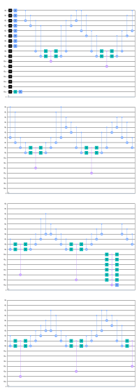 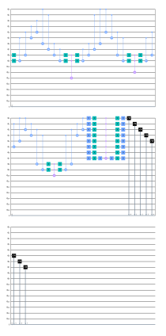

1. Design weighted target oracle operator
2. Construction of the quantum superposition state of the weighted targets



1. Based on Eq. 1) Oracle operator O can be constructed as follows



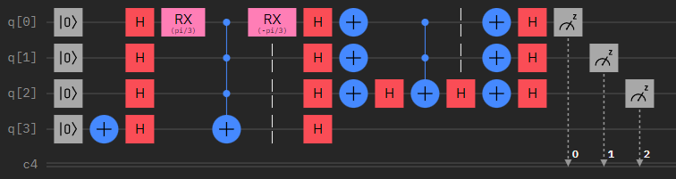

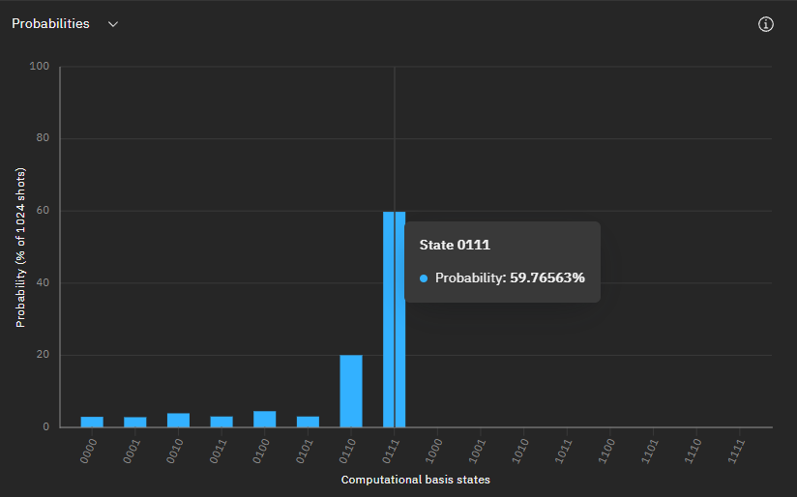

1. Applying weighted target Oracle to K-sat problem



… 진행중입니다.

1. QAOA

